Web Development: Lesson 6  
Moving to Azure Table Storage Hands-On Lab

## Overview

Building on the [Module 2 Lesson 5 Lab](https://github.com/MSFTImagine/computerscience/tree/master/Complimentary%20Course%20Content/Module2/Labs), we will implement a persistent storage solution for our microblog. Without a persistent storage solution, all your data will be lost every time your server crashes and every time you restart it. Obviously, your users won't tolerate such loss, so we need to implement persistent storage in the cloud.

## Objectives

In this hands-on lab you will learn how to:

* Implement CRUD using Azure Table Storage NoSQL remote database

## Prerequisites

The following are required to complete this hands-on lab:

* A code editor
* Windows PowerShell, Mac Terminal, or some other shell with node.js and npm installed
* You should have completed [Module 2 Lessons 1, 2, 3, 4, and 5](https://github.com/MSFTImagine/computerscience/tree/master/Complimentary%20Course%20Content/Module2/Lessons) as well as the [corresponding labs](https://github.com/MSFTImagine/computerscience/tree/master/Complimentary%20Course%20Content/Module2/Labs).

## Exercises

This hands-on lab includes the following exercises:

* Exercise 1: Moving to Azure Table Storage

## Exercise 1: Moving to Azure Table Storage

In this exercise, you will move locally stored data into Azure table storage. Note: Be sure to refer to the [Module 2 Lessons](https://github.com/MSFTImagine/computerscience/tree/master/Complimentary%20Course%20Content/Module2/Lessons) throughout this exercise. See [Module 1 Lesson 1](https://github.com/MSFTImagine/computerscience/blob/master/Complimentary%20Course%20Content/Module1/Labs/) for information on getting an Azure account.

NOTE: The following resource should prove helpful:

* <https://github.com/github/fetch>

The exercise involves the following steps:

1. Sign into the Azure portal (<https://portal.azure.com>). You should have a subscription from the [Module 1 Lesson 1 Lab](https://github.com/MSFTImagine/computerscience/tree/master/Complimentary%20Course%20Content/Module1/Labs).
2. Create a new project folder, and copy your [code/lesson5/lab2/app.js](https://github.com/MSFTImagine/computerscience/tree/master/Complimentary%20Course%20Content/Module2/code/lesson5/lab2) code to the folder.
3. Initialize your git repo creating the .gitignore file

git init

1. Create a file called start.sh. Add start.sh to .gitignore, using your favorite text editor Copy your key and storage name into start.sh. The code should look similar to the following:

AZURE_STORAGE_ACCOUNT=name AZURE_STORAGE_ACCESS_KEY=key node app.js

1. Create a file called test.sh. Add test.sh to .gitignore. Copy your key and storage name into test.sh. The code should look similar to the following:

AZURE_STORAGE_ACCOUNT=name AZURE_STORAGE_ACCESS_KEY=key ./node_modules/mocha/bin/mocha app.test.js

1. Use [code/lesson6/Lab/package.json](https://github.com/MSFTImagine/computerscience/tree/master/Complimentary%20Course%20Content/Module2/code/lesson6/Lab) and npm i to install azure-storage or install it manually
2. Modify app.js (Node/Express server code) to work with Azure storage so that each route such as GET, POST, PUT and POST work with the database and not with the in-memory array
3. Use npm test to verify that your server is working
4. Compare your solution with [code/lesson6/Lab/app.js](https://github.com/MSFTImagine/computerscience/tree/master/Complimentary%20Course%20Content/Module2/code/lesson6/Lab)
5. Add static middleware to serve content from public.

Let’s walk through each of these steps in details. Navigate to the Azure portal at https://portal.azure.com and sign in with the subscription you used in Lesson 1.

In the Azure Portal select **Storage accounts** from the left menu. 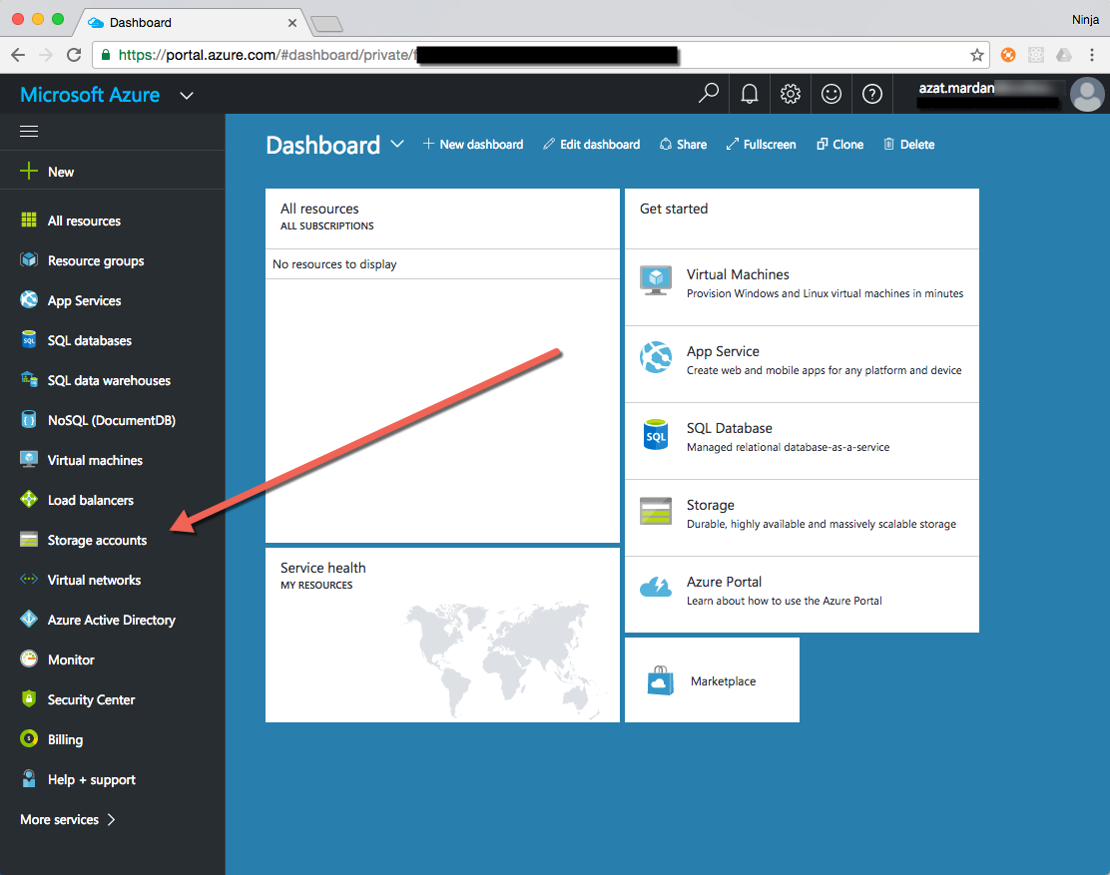

A list of storage accounts will be displayed. Select **+Add** to create a new storage account.

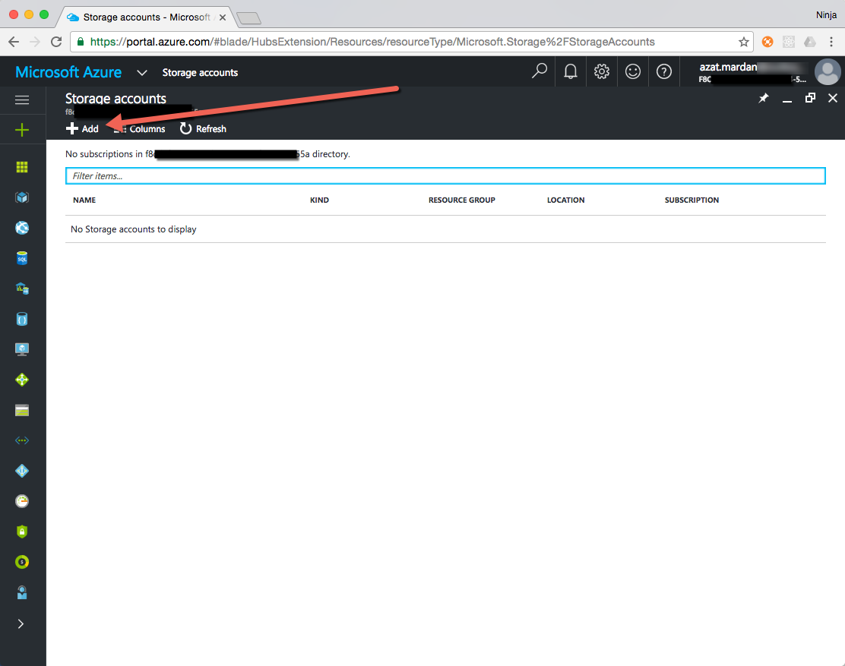

Enter a **Name** for your storage account. This name must be unique across Azure.

Leave **Account Kind**, **Performance**, **Replication**, **Storage Service Encryption**, and **Subscription** at their default values

For **Resource group**, select Create New and type in a name for the Resource group. A Resource group groups together the components use for your storage account for easier management.

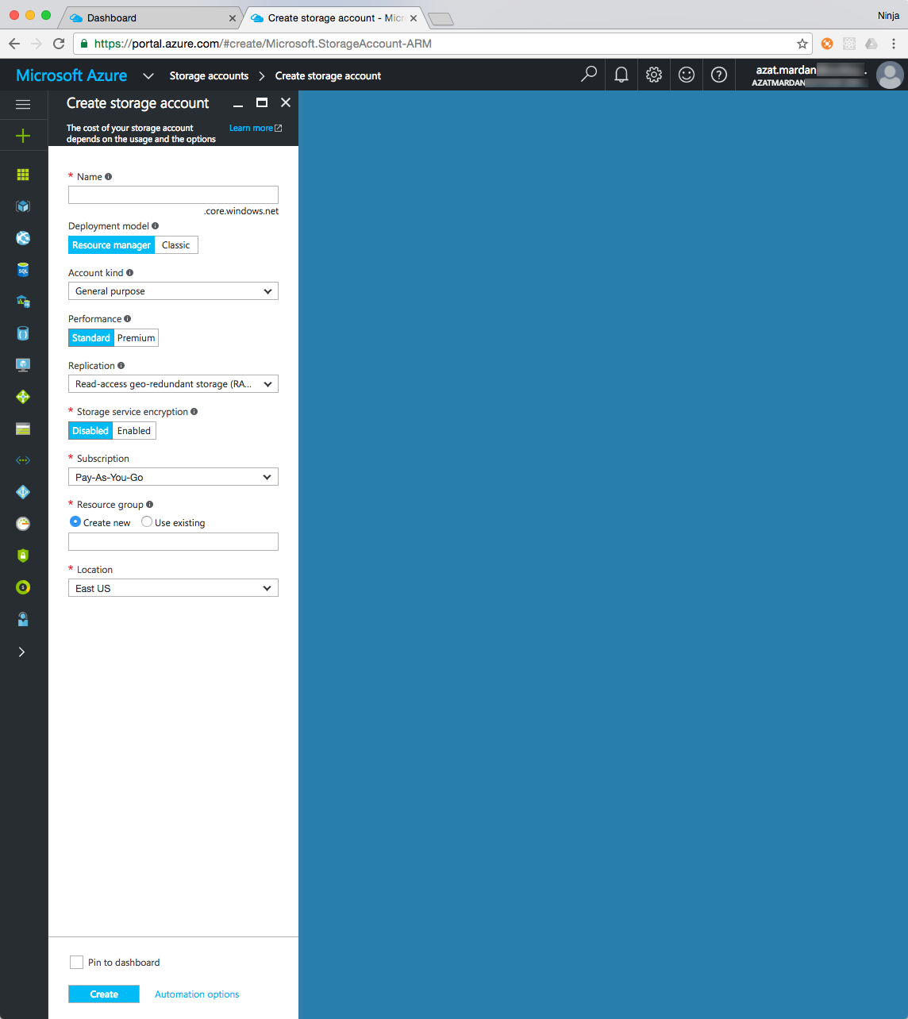

Once the storage account is created, you'll see it in the list of storage accounts.

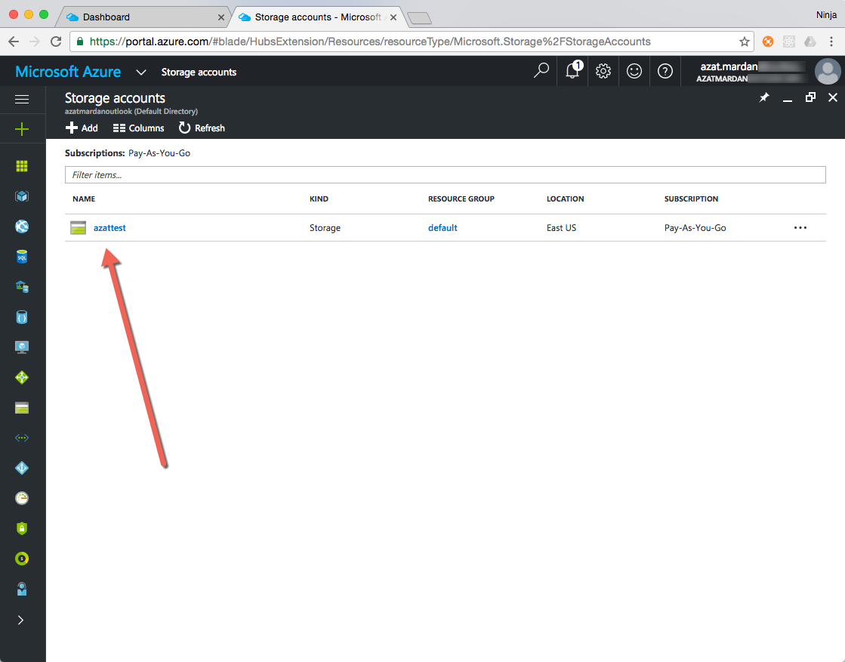

Select your Storage account which will open the storage account in a detailed Overview view as shown below. To access this storage account and its content from your code, you will need the keys. You can access the keys by selecting **Settings | Access Keys** in the left sidebar.

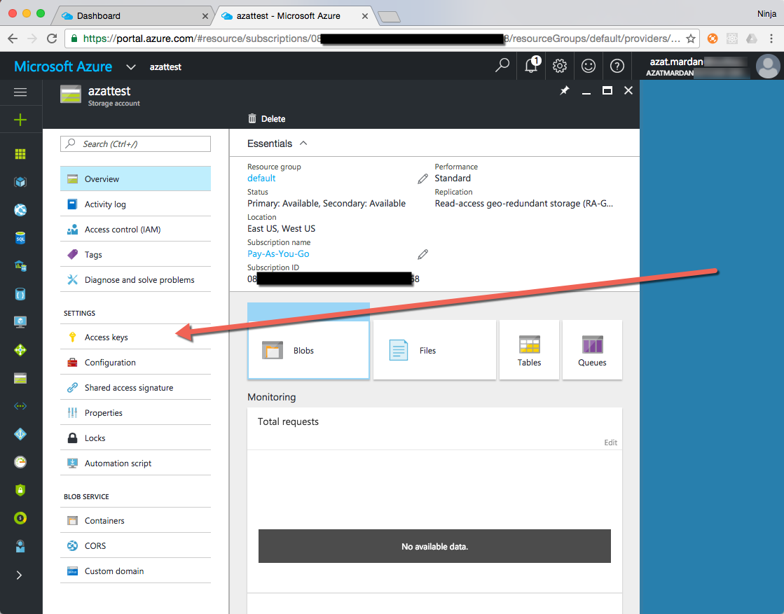

Copy the storage account name and the key. We will need them so our app can access the storage.

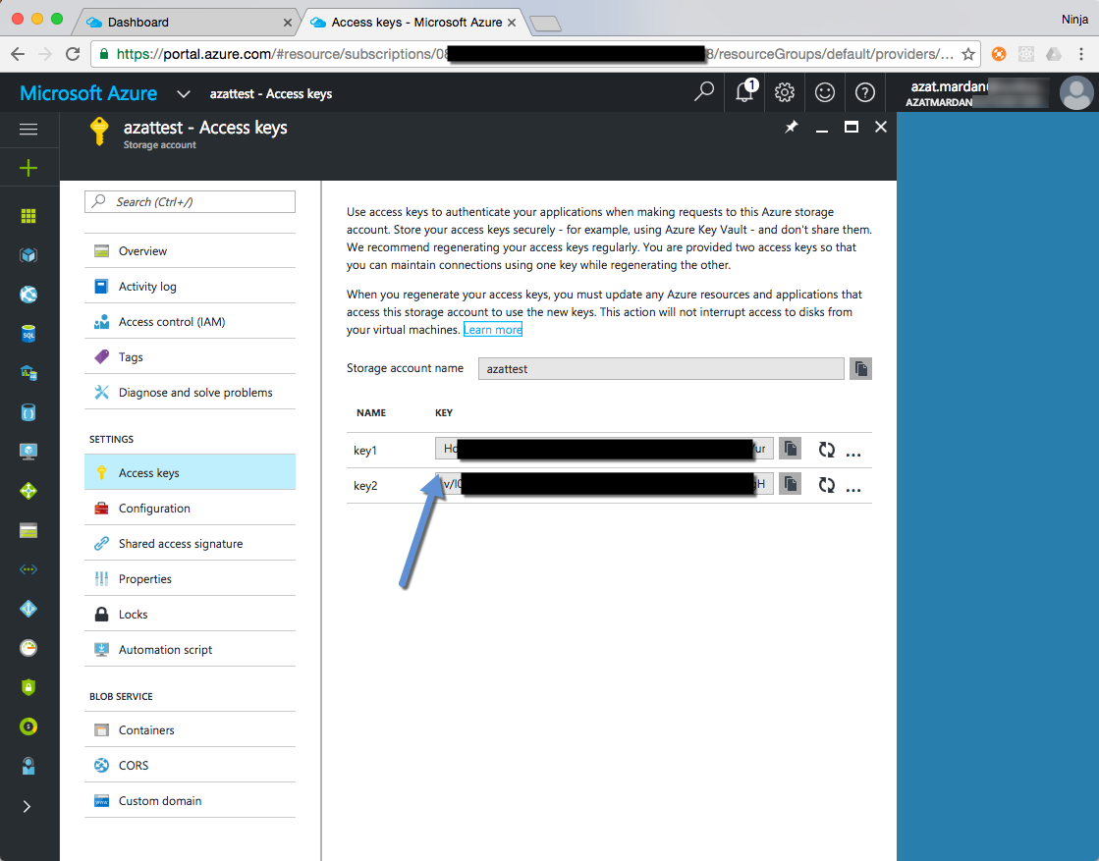

Now we can start coding.

Create a new folder for your project and navigate to that folder by executing the following commands:

$ mkdir azure-table

$ cd azure-table

Copy the files from the lab on REST services (module-2-lesson-5-lab) so we can build on the previously implemented project. The project structure will look like this when you are done.

/module-2-lesson-6-lab

/node_modules

.gitignore

app.js

app.test.js

package.json

README.md

start.sh

test.sh

Copy the key and name of the storage account you created in Azure to the shell files so our Node scripts can access those values from environment variables (environment variables are the best practice because they allow you to NOT store sensitive information in the source code).

1. Create a file called start.sh
2. Add the Azure key and storage name to start.sh in the following format

AZURE_STORAGE_ACCOUNT=name AZURE_STORAGE_ACCESS_KEY=key node app.js

1. Create a file called test.sh: AZURE_STORAGE_ACCOUNT=name .
2. Add the Azure key and storage name to test.sh in the following format:

AZURE_STORAGE_ACCESS_KEY=key ./node_modules/mocha/bin/mocha app.test.js

1. Add start script to package.json: "start": "sh start.sh" for convenience
2. Add test script to package.json: "test": "sh test.sh" for convenience

Install the azure-storage library so you can connect to Azure storage from Node by running the following command:

npm i azure-storage@1.0.1 -S

In the next section we will implement tests for the REST API. Once we have our tests written, we can use the following commands to execute the tests:

1. Run test. This first iteration will create the table.
   1. $ npm test
2. Run test again, this time to execute the test code with Azure.
   1. $ npm test
3. Run start to start the server on port 3000 with connection to Azure.
   1. $ npm start

Following the setup, we move on to implementing of the tests

**Implementing Azure Table REST API Tests**

The test file is very similar to the one where we used the in memory REST API except the Azure Table data will have a slightly different format. The data contains a RowKey._ field. We need to check for that field in our responses. (if you prefer, you can eliminate this field from your responses in the API server, then you won't need to test for it or use it on the client side. In the end, it comes down to the API design.)

At a higher level app.test.js has the following structure (the code for the functions is not shown):

var superagent = require('superagent')

var expect = require('expect.js')

var app = require('./app.js')

let baseUrl = 'http://localhost:3007/api'

before(function(){

// Prepare for the tests (optional)

})

describe('express rest api server', function(){

var id // ID shared between multiple it statements

it('posts an object', function(done){

// Create a new post

})

it('retrieves an object', function(done){

// Fetch the post

})

it('retrieves a collection', function(done){

// Fetch the list of posts

})

it('updates an object', function(done){

// Update the post

})

it('checks an updated object', function(done){

// Check that the updated post has new values

})

it('removes an object', function(done){

// Remove the post

})

it('checks an removed object', function(done){

// Check that the post is no longer present

})

})

after(function(){

// Clean up (Optional)

})

This is the final version of app.test.js filled in with the implementation details for the Azure Table REST API which tests CRUD for /posts:

var superagent = require('superagent')

var expect = require('expect.js')

const app = require('./app.js')

let baseUrl = 'http://localhost:3007/api'

before((done)=>{

app.listen(3007, done)

})

describe('express rest api server', function(){

var id

it('posts an object', function(done){

superagent.post(`${baseUrl}/posts`)

.send({ author: 'John',

text: `There's a better alternative to the ubiquitous JSON as the communication protocol of the web. It's Protocol Buffers (protobuf). In a nutshell, protobuf offers a more dense format (faster processing) and provides data schemas (enforcement of structure and better compatibility with old code). `

})

.end(function(e, res){

// console.log(res.body)

expect(e).to.eql(null)

expect(res.body['RowKey']._).to.be.ok

id = res.body['RowKey']._

done()

})

})

it('retrieves an object', function(done){

superagent.get(`${baseUrl}/posts/`+id)

.end(function(e, res){

// console.log(res.body)

expect(e).to.eql(null)

expect(typeof res.body).to.eql('object')

expect(res.body.RowKey._).to.be.ok

expect(res.body.RowKey._).to.eql(id)

expect(res.body.author._).to.eql('John')

done()

})

})

it('retrieves a collection', function(done){

superagent.get(`${baseUrl}/posts`)

.end(function(e, res){

// console.log(res.body)

expect(e).to.eql(null)

expect(res.body.length).to.be.above(0)

expect(res.body.map(function (item){return item.RowKey._})).to.contain(id)

done()

})

})

it('updates an object', function(done){

superagent.put(`${baseUrl}/posts/`+id)

.send({author: 'Peter', id: id})

.end(function(e, res){

// console.log(res.body)

expect(e).to.eql(null)

expect(typeof res.body).to.eql('object')

expect(res.body.msg).to.eql('success')

done()

})

})

it('checks an updated object', function(done){

superagent.get(`${baseUrl}/posts/`+id)

.end(function(e, res){

// console.log(res.body)

expect(e).to.eql(null)

expect(typeof res.body).to.eql('object')

expect(res.body.RowKey._).to.eql(id)

expect(res.body.author._).to.eql('Peter')

done()

})

})

it('removes an object', function(done){

superagent.del(`${baseUrl}/posts/`+id)

.end(function(e, res){

// console.log(res.body)

expect(e).to.eql(null)

expect(typeof res.body).to.eql('object')

expect(res.body.msg).to.eql('success')

done()

})

})

it('checks an removed object', function(done){

superagent.get(`${baseUrl}/posts/`)

.end(function(e, res){

// console.log(res.body)

expect(e).to.eql(null)

expect(res.body.map(function (item){return item.RowKey._})).to.not.be(id)

done()

})

})

})

after(()=>{

process.exit()

})

Because we have not yet implemented the features our test code is testing, running the tests now will most likely yield an error. We should add Azure to our server next.

**Implementing REST API with Azure Table**

Building upon the lab with in-memory storage REST API, we are going to start with this skeleton code in app.js, filling in implementation details in the subsequent steps.

var express = require('express'),

bodyParser = require('body-parser'),

logger = require('morgan'),

crypto = require('crypto')

//let posts = require('./posts.json')

let tableName = 'microblogdev'

let partitionKey = 'postsPartitionA'

var azure = require('azure-storage')

var tableSvc = azure.createTableService()

tableSvc.createTableIfNotExists(tableName, function(error, result, response){

// Error handling

})

var entGen = azure.TableUtilities.entityGenerator

var app = express()

app.use(bodyParser.json())

app.use(bodyParser.urlencoded({extended: true}))

app.use(logger('dev'))

app.get('/', function(req, res, next) {

res.send('please select a collection, e.g., /posts')

})

app.get('/api/posts', function(req, res, next) {

// Query Azure and send back the list of posts

})

app.post('/api/posts', function(req, res, next) {

// Create an object from JSON payload, insert into Azure Table and send back the results

})

app.get('/api/posts/:id', function(req, res, next) {

tableSvc.retrieveEntity(tableName,

partitionKey,

req.params.id,

function(error, result, response){

if (error) return next(error)

// result contains the entity

res.send(result)

}

)

})

app.put('/api/posts/:id', function(req, res, next) {

// Massage the incoming data and update the record in Azure Table, send back the results

})

app.delete('/api/posts/:id', function(req, res, next) {

// Prepare the data and remove the object/entity from the Azure Table storage

})

if (require.main === module) {

app.listen(3000, function(){

console.log('Express server listening on port 3000')

})

} else {

module.exports = app

}

Phew. Are you ready for the full source code implementation? Let's do it!

Import the npm modules we need: express, body-parser, and morgan.

crypto is not an npm module. It's a core module meaning it is already installed as part of Node platform and it'll be available to us to import. We need crypto to create unique IDs for the entities in the Azure Table.

var express = require('express'),

bodyParser = require('body-parser'),

logger = require('morgan'),

crypto = require('crypto')

Set the names of the table and partition key. We will be using these for subsequent API queries to post and retrieve blog entries in the next steps.

let tableName = 'microblogdev'

let partitionKey = 'postsPartitionA'

Import the azure-storage library which will allow us to connect to remote Azure storage, execute queries to fetch and update data.

var azure = require(‘azure-storage')

Before we can work with the data we need to create the table. We can use createTableService() to get the table service object and then createTableIfNotExists which as you might guess will create a new table if it does NOT exist already. This way, every time we start a server, it will make sure we have a table to work with. The best practice is to handle errors in each callback which we can do by checking for !error, i.e. error is not null.

Azure will be able to locate *your account* is because you put the storage account name and the access key into the shell script. The shell script will populate environment variables which will be used by the azure-storage library to make the connection.

var tableSvc = azure.createTableService()

tableSvc.createTableIfNotExists(tableName, function(error, result, response){

if(!error){

console.log('Table exists or created', result)

} else {

console.log('Error creating table', error)

}

})

We can create an alias for entityGenerator with the azure-storage library. Later on we can refer to this alias to create Azure Table entities.

var entGen = azure.TableUtilities.entityGenerator

Instantiate the Express app and apply the middleware:

var app = express()

app.use(bodyParser.json())

app.use(bodyParser.urlencoded({extended: true}))

app.use(logger('dev'))

Everything is ready to start implementing routes. The first will be GET to / and /posts. The former is straightforward while the latter will need a query object we create with azure.TableQuery(). The query is limited by top and where clauses. We fetch the data using the table name and query. In the callback, we check if the error is null and send results to the client using res.send().

app.get('/', function(req, res, next) {

res.send('please select a collection, e.g., /posts')

})

app.get('/api/posts', function(req, res, next) {

var query = new azure.TableQuery()

.top(100)

.where('PartitionKey eq ?', partitionKey) // Use partition key

tableSvc.queryEntities(tableName, query, null, function(error, result, response) {

if (error) return next(error) // Ooops, error. Exit.

// Query was successful

res.send(result.entries)

})

})

Next, implement the insertion of new posts which is POST to /api/posts. This route will need the help of crypto to generate a unique ID based on the author name (req.body.author) and the current timestamp (Date.now()).

app.post('/api/posts', function(req, res, next) {

let id = `${req.body.author}${Date.now()}`

// console.log(id)

id = crypto.createHash('sha256').update(id).digest('hex')

After we generate the ID we can form the entity to store in the table. The structure of Azure Table entities is not the same as JSON. It uses _. You can use entGen or do it manually as shown below:

var task = {

PartitionKey: {'_':partitionKey},

RowKey: {'_': id},

author: {'_': req.body.author},

text: {'_': req.body.text},

createdAt: {'_': new Date(2015, 6, 20), '$':'Edm.DateTime'}

}

Now, you can use insertEntity to inject the new entity into your table. echoContent will show you the resulting entity in the response argument of the callback. We need it to send the newly created data back to the client.

tableSvc.insertEntity(tableName,

task,

{echoContent: true},

function (error, result, response) {

if (error) return next(error) // Oops, something went wrong

res.send(result) // Entity inserted, send it to the client

})

})

So far we haven't implemented fetching an individual post. We can do it with retrieveEntity. All we need is to provide the table name, partition key, and the entity ID. You got the data in the result so we can send it back to the client.

app.get('/api/posts/:id', function(req, res, next) {

tableSvc.retrieveEntity(tableName,

partitionKey,

req.params.id,

function(error, result, response){

if (error) return next(error)

res.send(result) // result contains the entity

}

)

})

For the next route (update post), we check for the presence of author or text fields and form the object updatedPost accordingly. We use updatedPost in replaceEntity which takes table name and the data as arguments. The partition key must be part of the updatedPost so tableSvc could find the entity.

app.put('/api/posts/:id', function(req, res, next) {

let updatedPost = {}

if (req.body.author)

updatedPost.author = {'_': req.body.author}

if (req.body.text)

updatedPost.text = {'_': req.body.text}

updatedPost.PartitionKey = {'_': partitionKey}

updatedPost.RowKey = {'_': req.params.id}

tableSvc.replaceEntity(tableName, updatedPost, function(error, result, response){

if (error) return next(error)

// Entity updated

res.send({msg:'success'})

})

})

We need to be able to remove the posts in our microblog. Hence, the DELETE /api/posts route which uses partition key and row key (entity key) to remove the entity in a table. deleteEntity uses table name along with the post object which has partition and entity keys. We get the URL parameter :id from req.params.id. We send a success message if there were no errors.

app.delete('/api/posts/:id', function(req, res, next) {

let post = {}

post.PartitionKey = {'_': partitionKey}

post.RowKey = {'_': req.params.id}

tableSvc.deleteEntity(tableName, post, function(error, response){

if (error) return next(error)

// Entity deleted

res.send({msg: 'success'})

})

})

The rest of the code is copied from the previous lab. It starts up a server if this script was launched as a standalone Node program (node app.js), or exports the code if this script was imported (require('./app.js')) from another module such as test app.test.js.

if (require.main === module) {

app.listen(3000, function(){

console.log('Express server listening on port 3000')

})

} else {

module.exports = app

}

At this point, if you implemented everything correctly, you should be able to run the tests successfully. Remember, you may need to run the following command twice; once to create the storage table and a second time to run the tests:

$npm test

You should get a similar result to the screenshot below except for the etag and ID values.

express rest api server

Table exists or created { isSuccessful: true,

statusCode: 200,

TableName: 'microblogdev',

created: false }

POST /api/posts 200 834.654 ms - 772

✓ posts an object (878ms)

GET /api/posts/5aa67eb9b1e28a18d35788d25cac9f259bf04d8e197549c66570ff09c7281bdc 200 549.715 ms - 772

✓ retrieves an object (560ms)

GET /api/posts 200 505.700 ms - 688

✓ retrieves a collection (512ms)

{ '.metadata': { etag: 'W/"datetime\'2016-11-16T22%3A40%3A26.964605Z\'"' } }

PUT /api/posts/5aa67eb9b1e28a18d35788d25cac9f259bf04d8e197549c66570ff09c7281bdc 200 510.261 ms - 17

✓ updates an object (515ms)

GET /api/posts/5aa67eb9b1e28a18d35788d25cac9f259bf04d8e197549c66570ff09c7281bdc 200 514.358 ms - 400

✓ checks an updated object (518ms)

DELETE /api/posts/5aa67eb9b1e28a18d35788d25cac9f259bf04d8e197549c66570ff09c7281bdc 200 517.220 ms - 17

✓ removes an object (521ms)

GET /api/posts/ 200 530.480 ms - 2

✓ checks an removed object (534ms)

If you have any errors, check your code against the solution provided in the repository.

Note: if you are getting *StorageError: Server failed to authenticate the request. Make sure the value of Authorization header is formed correctly including the signature*, then make sure you have the proper storage account name and the access key populated in the environment variables. Check your start.sh and test.sh.

Feel free to start the server in a standalone mode with npm start and try to insert and fetch the data with Postman or CURL. It's fun to watch that your data is persistent in a cloud meaning even if you kill the server (close the terminal or kill the process), the data is safely stored in the cloud and can be accede later by a new instance of the server or from other clients.

## Summary

In this hands-on lab, you learned how to:

* Transfer data into Azure Table Storage
* Use azure-storage Node module
* Form Azure Table entities manually